RECORD OF PROCEEDINGS
PHYSICAL DISABILITY BOARD OF REVIEW

NAME: XXXXXXXXXXXXXXXXX BRANCH OF SERVICE: ARMY
CASE NUMBER: PD0900186 BOARD DATE: 20091124
SEPARATION DATE: 20080126
________________________________________________________________

SUMMARY OF CASE: This covered individual (CI) was an active duty NCO (infantry) medically separated from the Army in 2008 after 17 years of service. The medical bases for the separation were thoracic outlet syndrome (TOS) and bilateral hearing loss. He was involved in a Humvee accident in October, 2004. He subsequently developed left chest, left neck and left (dominant side) shoulder pain. He underwent negative cardiac, cervical and orthopedic work-ups and was treated conservatively. In 2006 he was referred to a thoracic surgeon who diagnosed TOS (pressure on the left arm nerve root as it exits the thorax). He underwent nerve blocks, physical therapy (PT) and medication trials without significant relief and remained with a U3 profile. The CI also had long-standing hearing loss, presumably related to his mortar MOS, which worsened to the point of requiring a hearing aid and resulted in a permanent H3 profile. Neither of these profiles was compatible with his MOS and he underwent an MEB. Both conditions were determined to be medically unacceptable and he was referred to the PEB. Other conditions identified before or during the MEB process included obstructive sleep apnea (OSA), chronic renal insufficiency, exercise induced asthma, gastroesophageal reflux disease (GERD) and hypertension. These conditions had been previously evaluated, were discussed in the NARSUM and were forwarded on the MEB’s DA 3947 as medically acceptable conditions. There was an orthopedic consultation for left ankle pain during the MEB process, but none of the orthopedic conditions noted as contentions below were clinically active during the MEB process. An informal PEB found the CI to be unfit for TOS and hearing loss (rated 20% and 0% respectively) and not unfit for the remaining conditions. A request for reconsideration by the USAPDA resulted in administrative change to the diagnostic description of TOS, but did not affect rating. The CI was separated with a 20% combined disability rating.
________________________________________________________________

CI CONTENTION: The CI’s application states, ‘I was given a medical disability rating by the Army of 20%, on Saturday, January 26, 2008. I was discharged one day before (on a Saturday) the Army would have been required to evaluate my case based on VASRD. Had the Army not rushed to dismiss me in order to avoid a fair evaluation of my discharge, I would have been evaluated based on VASRD and granted a Medical Retirement with a disability rating of greater than 30%...I request that my discharge date be adjusted and corrected to reflect January 28, 2008 - the next business day. I request that my complete medical history be included in evaluating my discharge based on all service connected ailments that were evaluated and approved by the VA.’ In addition to requesting separation ratings for all of the conditions identified on his MEB DA 3947, he requests ratings for ‘bilateral tinnitus’, ‘left lower extremity weakness associated with thoracic outlet syndrome’, ‘left knee strain’ and ‘right knee strain’.

The implication of the separation date, a significant issue in the CI’s view, apparently arises from the effective date of the National Defense Authorization Act of 2008. His contended conditions include every service connected and compensated condition as they appear on the VA rating decision. This implies an assumption that NDAA 2008 mandated that all service connected conditions, independently of fitness determination, are subject to separation disability ratings under the VASRD. The scope of NDAA 2008, of course, was confined to the rating of unfitting conditions IAW the VASRD (vs. DOD or service regulations). The PEB ratings of the conditions determined to be unfitting in this case were, in fact, compliant with NDAA 2008. The Board will review the fairness of the PEB’s fitness adjudications and any Board rating recommendations will, of course, be concordant with NDAA 2008. A change in separation date, albeit a BCMR and not PDBR matter, would therefore have no effect on the disability rating or Board recommendations in this case.
________________________________________________________________

RATING COMPARISON:

Service PEB |  |  |  | VA (1 Mo. after Separation)
Condition | Code | Rating | Date | Condition |  | Code | Rating | Exam | Effective
Thoracic Outlet Syndrome… | 8599-8513 | 20% | 20071210 | Left Upper Extremity Weakness A/W Thoracic Outlet Syndrome |  | 8515 | 10% | 20080228 | 20080127
Bilateral Hearing Loss | 6100 | 0% | 20071210 | Bilateral Hearing Loss |  | 6100 | 0% | 20080228 | 20080127
Sleep Apnea | Not Unfitting |  | 20071210 | OSA |  | 6847 | 50% | 20080228 | 20080127
Chronic Renal Insufficiency | Not Unfitting |  | 20071210 | Incorporated with hypertension. |  |  |  | 20080228 | 20080127
Exercise Induced Asthma | Not Unfitting |  | 20071210 | Incorporated with OSA. |  |  |  | 20080228 | 20080127
GERD | Not Unfitting |  | 20071210 | GERD | 7399-7346 |  | 10% | 20080228 | 20080127
Hypertension | Not Unfitting |  | 20071210 | Hypertension |  | 7101 | 0% | 20080228 | 20080127
No DA 3947 Entry. |  |  |  | Bilateral Tinnitus |  | 6260 | 10% | 20080228 | 20080127
No DA 3947 Entry. |  |  |  | Left Lower Extremity Weakness A/W Thoracic Outlet Syndrome |  | 8520 | 10% | 20080228 | 20080127
No DA 3947 Entry. |  |  |  | Left Knee Strain |  | 5260 | 10% | 20080228 | 20080127
No DA 3947 Entry. |  |  |  | Right Knee Strain |  | 5260 | 10% | 20080228 | 20080127
No Additional DA 3947 Entries. |  |  |  | Non-PEB X 4 / NSC X 0 |  |  |  | 20080228 | 20080127
TOTAL Combined: 20% |  |  |  | TOTAL Combined (Includes Non-PEB Conditions): 80%
________________________________________________________________

ANALYSIS SUMMARY:

Thoracic Outlet Syndrome. The PEB code for the condition is consistent with the Table of Analogous Codes in use by the USAPDA and reflects the peripheral nerve code for impairment of all radicular groups to the arm. This is a good fit with the pathology of this case and more accurate than the median nerve code applied by the VA. It also yields the higher rating. Coding under the shoulder joint code would be disadvantageous to the CI, since the range of motion impairment was non-compensable under 5201. The main issue facing the Board, then, is whether the impairment is more consistent with the ‘mild’ incomplete paralysis rating under 8513, as per the PEB, or ‘moderate’ rating (40% for the dominant extremity). The basis of the USAPDA-directed reconsideration was in regard to this same question. The initial DA 199 description of TOS included the phrase ‘muscle strength 4/5 in left upper extremity’. This physical finding was reflected in the MEB’s PT exam, but was not included in the NARSUM or specialty addendums. The DA 199 also referenced an EMG (nerve conduction study) finding of ‘mild left ulnar neuropathy’. The USAPDA memo returning the case for reconsideration is excerpted below:

The 199 disability description does not provide a rationale for why the PEB rated this at "mild incomplete paralysis," i.e., 20%, versus something higher. Generally, peripheral nerve injuries are rated on a continuum with the highest rating, i.e., complete paralysis, being complete loss of motor and sensory function and the lowest being (only) purely sensory loss...If the PEB is satisfied that the Soldier has true motor weakness, the Soldier's condition warrants a rating higher than 20%. However, it is not clear whether the Soldier's decreased muscle strength represents the Soldier exerting maximal force against the examiner or whether the Solder is stopping short of maximal effort because of pain. The neurologist should be able to provide additional information addressing this issue. For example, muscle atrophy and EMG findings may clarify whether the Soldier has a true motor deficit. The PEB should clarify the significance of the Soldier's EMG findings of ‘ulnar neuropathy’ in light of the fact that the PEB rated the Soldier for ‘incomplete paralysis of all radicular groups.’

In response to the USAPDA direction, the MEB repeated the EMG study and obtained neurologic consultation. The repeat EMG was essentially normal, notwithstanding a comment ‘except there may be very mild slowing in the conduction velocity of the left ulnar motor nerve across the wrist’. This caveat is not clinically significant nor is it relevant to the pathology of TOS. The neurologist stated, ‘Motor examination does not show any significant weakness in his upper extremities, particularly his left arm. He may have mild giveaway weakness in his left arm, which is both proximal and at times distal. This does not fall into any anatomic distribution.’ The minor caveats are, once again, not of a clinical significance which would influence rating. The USAPDA memo in response to the PEB’s reconsideration is excerpted below:
The Physical Evaluation board has reviewed the case on the Soldier named above and solicited input from the treating neurologist as directed by the PDA. It would appear that the Soldier is appropriately rated as no significant muscle strength is lost, there is no atrophy, and at best, may have mild slowing in the ulnar motor nerve as determined by EMG.
It would appear, therefore, that the PEB’s defense of the ‘mild’ characterization for purposes of rating under 8599-8513 was on sound footing. It should also be noted that the Thoracic Surgery consultant documented a ‘5/5’ exam and that there are various entries in the service medical record (including the MEB physical) noting normal left arm strengths. The VA rating examiner, on the other hand, noted left arm motor strengths as ‘4/5’. The VA decision, however, still applied the ‘mild’ rating under the chosen peripheral nerve code. This illustrates the fact that there is no specific VASRD direction for distinguishing the ‘mild’, ‘moderate’ and ‘severe’ rating classifications for incomplete paralysis in regards to the peripheral nerve codes. Even conceding some mild, and perhaps intermittent, motor weakness, it does not follow that the impairment jumps from ‘mild’ to ‘moderate’. That is especially true for codes, such as this one, where this relatively minor functional difference would translate into doubling the disability rating. All evidence considered, there is not reasonable doubt in the CI’s favor supporting Board recommendation for a higher rating under 8599-8513 in this case.
Hearing Loss. This condition was determined to be unfitting by the PEB. Although the Army used the SPRINT exam for speech discrimination, the VASRD-mandated Maryland CNC test was performed by the VA within a month of separation. This yielded speech recognition scores of 96% for the right ear and 92% for the left ear, significantly higher than the overall 78% SPRINT score. Coupling the Maryland CNC results to either the audiology results from the MEB or the VA would still yield a non-compensable rating. A recommendation of no recharacterization of the PEB’s adjudication for the bilateral hearing loss condition is therefore indicated.
OSA and Exercise Induced Asthma. OSA was diagnosed by a sleep study in 2003 and was stabilized on CPAP (nocturnal assisted breathing device) by the time of the MEB. The asthma condition was also stable on medications and diagnosed well in advance of the MEB. The VA rating examiner commented that ‘He has some dyspnea once a week which has been controlled since he has been on Advair and albuterol.’ The CI was still followed by pulmonology with periodic readjustments of his CPAP at the time of the MEB, but there is no indication that either pulmonary condition had deteriorated over the few years prior to the MEB. OSA and the need for CPAP were covered by his medical profile, although it is unclear if this was the only foundation for the P3 designation. Neither pulmonary condition was noted in the Commanders Performance Statement. Both conditions were judged by the MEB to be within AR 40-501 retention standards. OSA is not generally judged to be unfitting by PEB’s across the services, and the mild severity of the CI’s exercise induced asthma condition would not be expected to independently render a service member unfit. All evidence considered, there is not reasonable doubt in the CI’s favor supporting recharacterization of the PEB fitness adjudications for the OSA or asthma conditions.
GERD. The NARSUM stated that the CI underwent an endoscopic surgical procedure for the condition in June, 2000 with ‘poor result’, but that he ‘has continued on proton pump inhibitor medications since that time with good results’. There is no record of any vomiting, diarrhea, protracted pain or any other incapacitating symptoms active at the time of separation. The condition does not appear in the Commanders Performance Statement or medical profile. It was judged by the MEB to be within AR 40-501 retention standards. All evidence considered, there is not reasonable doubt in the CI’s favor supporting recharacterization of the PEB fitness adjudications for the GERD condition.

Chronic Renal Insufficiency and Hypertension. These are both chronic, stable medical conditions which would not be expected to impact fitness. Hypertension was diagnosed in 2003 and was stable on medications. Proteinuria and compromised kidney function were detected by laboratory findings in 2004. This was asymptomatic and stable. There was never an indication for dialysis and the CI was subject only to annual reevaluations by nephrology. Both conditions were within AR 40-501 retention standards and there is no question that the PEB’s fitness adjudication for these conditions was appropriate.

Other Conditions. Other than tinnitus (virtually never unfitting), all of the other conditions compensated by the VA, but not forwarded to the PEB for fitness adjudication, were orthopedic in nature. These included bilateral knee strain conditions and a left leg weakness attributed to TOS. The CI was evaluated by orthopedics for a left ankle condition during the MEB, but this was not linked to fitness and rated 0% by the VA. These conditions were identified at the time of the VA rating examination, but were not in evidence on the MEB physical or in the NARSUM. They are therefore not in the DES packet for Board consideration, nor is there any evidence that would make a case for any of them as additionally unfitting conditions. Incidental note is made that the VA linkage of lower extremity weakness with TOS is not compatible with the anatomic pathology of the condition. The profile was L1 and the Commanders Performance Statement did not mention any orthopedic limitations other than the shoulder. The Board, therefore, has no reasonable basis for recommending any additional unfitting conditions for separation rating.
________________________________________________________________

BOARD FINDINGS: IAW DoDI 6040.44, provisions of DoD or Military Department regulations or guidelines relied upon by the PEB will not be considered by the Board to the extent they were inconsistent with the VASRD in effect at the time of the adjudication. The Board did not surmise from the record or PEB ruling in this case that any prerogatives outside the VASRD were exercised. As discussed above, it is clarified for the applicant that the PEB’s adjudication was compliant with all of the requirements of the National Defense Authorization Act, effective January 28, 2008. In the matter of the thoracic outlet syndrome condition and IAW VASRD §4.124a, the Board unanimously recommends no recharacterization of the PEB coding or rating. In the matter of the bilateral hearing loss condition and IAW VASRD §4.87, the Board unanimously recommends no recharacterization of the PEB coding or rating. In the matter of the sleep apnea, chronic renal insufficiency, exercise induced asthma, gastroesophageal reflux and hypertension conditions; the Board unanimously recommends no recharacterization of the PEB adjudication as not unfitting. In the matter of the tinnitus, left lower extremity weakness, left and right knee strains and all of the CI’s other medical conditions; the Board unanimously agrees that it cannot recommend a finding of unfit for additional rating at separation.
________________________________________________________________

RECOMMENDATION: The Board therefore recommends that there be no recharacterization of the CI’s disability and separation determination.

We note the applicant asks the Board for specific correction of records and specified consequential entitlements. By law the Board authority is limited to making recommendation on correcting disability determinations. The actual correction of records and consequential entitlement determinations is the responsibility of the applicable Secretary and Accounting service. The applicant's request will of course remain with the application as it is processed.
________________________________________________________________

The following documentary evidence was considered:

Exhibit A. DD Form 294, dated 20090227, w/atchs.
Exhibit B. Service Treatment Record.
Exhibit C. Department of Veterans' Affairs Treatment Record.

President
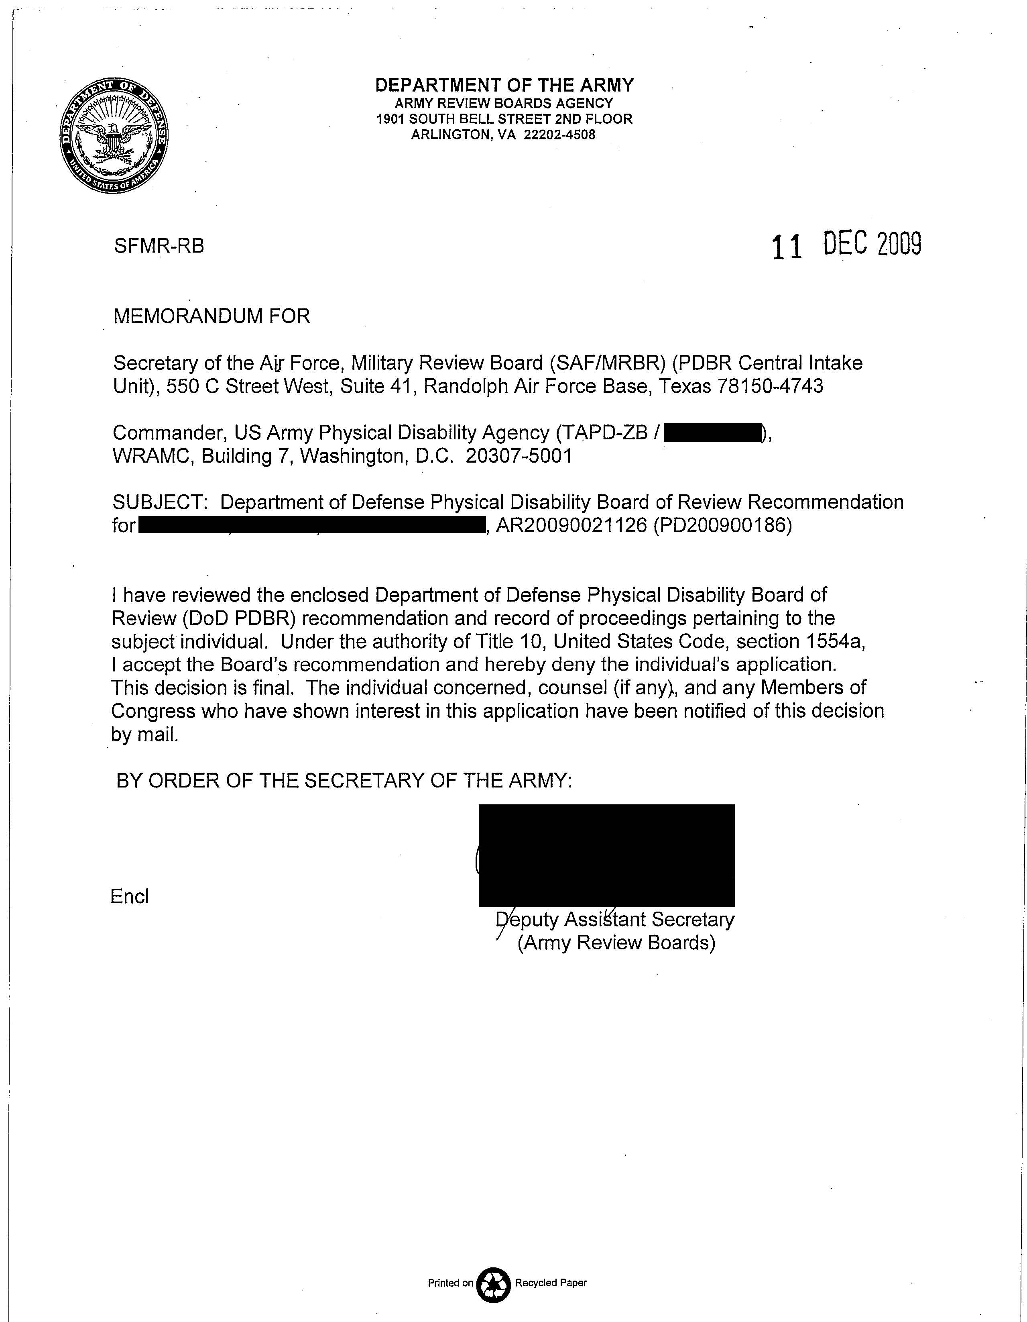
Physical Disability Board of Review

