RECORD OF PROCEEDINGS
PHYSICAL DISABILITY BOARD OF REVIEW

NAME: BRANCH OF SERVICE: marine corps
CASE NUMBER: PD0900136 BOARD DATE: 20090819
SEPARATION DATE: 20050930
________________________________________________________________

SUMMARY OF CASE: This covered individual (CI) was Marine Staff Sergeant Calibration and Repair Technician medically separated from the Marine Corps in 2005 after eighteen years of total service. The medical basis for the separation was Left knee arthrosis.

The CI injured his left knee with a twisting/hyperextension during a cutting movement while playing Battalion flag football. He did not require crutches but did have his activity restricted. He was treated conservatively but his pain continued and he was referred to orthopedics. An MRI done in May 2004 led to the diagnosis of left knee arthrosis. Glucosamine and medial unloader brace were tried along with activity modifications and physical therapy and nothing provided any benefit. He was unable to run at all secondary to the pain and this condition, along with neck pain and numbness which radiated down his left arm into his thumb and index finger, rendered him unfit to perform the duties of his rank and rating and he was referred to the Navy Physical Evaluation Board (PEB) while on his second LIMDU.

The Navy Informal PEB determined he was fit for continued military service. However, the CI asked for reconsideration and submitted a personal statement and a non-medical assessment from his new Commander. The Informal PEB then determined he was unfit for continued service and he was then separated with a 0% disability for 5299-5003 Left Knee Arthrosis using the Veterans Affairs Schedule for Ratings Disabilities (VASRD) and applicable Navy and Department of Defense regulations.
________________________________________________________________

CI CONTENTION: ‘The Physical Evaluation Board rated cervical spondylosis as a category III condition and did not rate it as unfitting. The VA has rated cervical spondylosis and the radiculopathy, C6 at 20%. Request the board review and re-evaluated my disability rating.’
________________________________________________________________

RATING COMPARISON:

Previous Determinations
Service exam 20050414 |  |  |  | VA exam 1 month pre-separation: 20050824
PEB Condition | Code | Rating | Date | Condition | Code | Rating | Exam Date | Effective date
Left Knee Arthrosis | 5299-5003 | 0 | 20050815 | Arthrosis Left Knee | 5260 | 10 | 20050824 | 20051001
Cervical Spondylosis |  | Not unfitting | 20050815 | Foraminal Stenosis and Arthritis, Cervical Spine | 5010-5237 | 10 | 20050824 | 20051001
 |  |  |  | Radiculopathy, C6, Left Thumb And Index Finger | 8515 | 10 | 20050824 | 20051001
 |  |  |  | Scar, Right Thigh | 7804 | 0 | 20050824 | 20051001
 |  |  |  | Eczema | 7806 | 0 | 20050824 | 20051001
 |  |  |  | DJD, Lumbar Spine | 5010-5237 | 0  10 | 20050824  20060330 | 20051001  20051001
TOTAL Combined: 0% |  |  |  | TOTAL Combined (incl non-PEB Dxs): 30% from 20051001

ANALYSIS SUMMARY:

Left knee arthrosis
Navy 5299-5003:
MRI May 2004 showed irregular cartilage overlying the medial femoral condyle and a Baker cyst. Navy MEB exam showed ROM of 0-130 degrees, same as VA exam. However, Navy exam did not comment on pain with motion or repetitive motion. No instability was noted. X-Rays done 20050127 showed diffuse degenerative changes.

VA 5260:
Using an evaluation completed one month prior to the time of separation from the Marine Corps, the Veterans Administration (VA) rated this disability as 5260 Left Knee Arthrosis at 10%. The VA exam showed ROM of 0-130 degrees, same as Navy exam. However, VA noted there was increased pain with repetitive motion. The VA exam also documented left knee tenderness over the inferior patella, mild tenderness over the medial joint line, and mild popliteal tenderness. No instability was noted.

Analysis:
Either code could be used and regardless of which code was chosen, the rating would be based on painful motion. There is no knee joint instability. The limitation of range of motion of the knee is not sufficient to meet the criteria for the lowest compensable rating without consideration of painful motion as described in 5003 and paragraph 4.59. A rating of 10% is based on painful motion.

Cervical spondylosis with foraminal stenosis and arthritis
Navy:
The Navy PEB acknowledged this diagnosis but determined it was not unfitting. The rationale for this decision is not available. An MRI that was done 20050209 showed multilevel cervical spondylosis which is most significant at C5-6 producing moderate left foraminal narrowing and mild central canal stenosis. The NARSUM mentions symptoms of neck, shoulder, and arm pain; throbbing in these areas of pins and needles to the left thumb is consistent with the CI’s diagnosis of cervical spondylosis.

VA:
Using an evaluation completed one month prior to the time of separation from the Marine Corps, the VA rated this disability as 5010-5237 Foraminal Stenosis and Arthritis, Cervical Spine at 10%. Exam showed range of motion (ROM) which rates at 10% for total ROM at 285 degrees. Cervical flexion was 45 degrees, extension and right and left lateral flexion were 30 degrees each, right rotation was 80 degrees, and left rotation was 70 degrees. History revealed difficulty working overhead and drives longer than one hour. Physical therapy and NSAIDS initially helped with symptoms but when he went back to work his pain returned.

Analysis:
The Navy PEB considered this condition to be Category III: Conditions that are not separately unfitting and do not contribute to the unfitting condition. However, the Commander’s letter dated 20050708 specifically states that both the knee condition and the neck condition with numbness in left shoulder and several fingers of his left hand (radiculopathy) rendered the CI incapable of performing his primary duties as Metrology/Calibration Program Manager and as a result he was reassigned to another billet within his work center.

Cervical radiculopathy (C6)
Navy:
An MRI that was done 20050209 showed multilevel cervical spondylosis which is most significant at C5-6 producing moderate left foraminal narrowing and mild central canal stenosis. The NARSUM states there was a history of neck, shoulder, and arm pain, throbbing in these areas of pins and needles to the left thumb. Pain is 80% neck pain and 20% arm pain. No ROM exam was done. Motor was 5/5 bilateral upper extremities and sensory was intact in all dermatomes in bilateral upper and lower extremities. Radiograph showed foraminal stenosis on the left C6 with associated facet hypertrophy. Condition was felt to be degenerative in nature and surgery was not indicated.

VA:
Using an evaluation completed one month prior to the time of separation from the Marine Corps, the VA rated this disability as 8515 Radiculopathy, C6, Left Thumb and Index Finger at 10%. Exam showed range of motion (ROM) which rates at 10% for total ROM at 285 degrees. Exam noted decreased sensation to monofilament over left thumb and index fingers. NO motor weakness. Normal ROM of hand including the thumb. Neck pain is described as dull and achy and CI had persistent mild dysesthesia in the left thumb and index finger.

Analysis:
The Navy PEB did not consider this condition but it is mentioned in the addendum to the MEB that addresses the diagnosis of cervical spondylosis and in the MEB History and Physical. However, the Commander’s letter dated 20050708 specifically states that both the knee condition and the neck condition with radiculopathy rendered the CI incapable of performing his primary duties as Metrology/Calibration Program Manager and as a result he was reassigned to another billet within his work center.

MRI shows foraminal stenosis and pressure on the nerve root involved in the radiculopathy, C6, and this is consistent with the VA exam finding of decreased sensation in the C6 dermatome. This contradicts with the Navy sensory exam but the C&P exam appears to be more thorough and more probative value can be placed on it.

DJD, Lumbar spine, Scar Right Thigh from Abscess, and Eczema
Navy:
Mentioned in history of MEB H&P by CI but not addressed by health care provider. No evidence to add this as an unfitting condition; not in Commander’s letter.

VA:
Rated as above.
________________________________________________________________

BOARD FINDINGS BOARD FINDINGS: IAW DoDI 6040.44, provisions of DoD or Military Department regulations or guidelines relied upon by the PEB will not be considered by the PDBR to the extent they were inconsistent with the VASRD in effect at the time of the adjudication. After careful consideration of all available information, the Board concluded by simple majority that the CI’s condition is appropriately rated at a combined 30% using the VASRD, including the general rating formula for diseases and injuries of the spine. The 30% rating is comprised of three ratings of 10% each for 5299-5003 Left Knee Arthrosis, 5010-5237 Cervical Spondylosis with C5-C6 Left Foraminal Stenosis and Arthritis, and 8515 Radiculopathy, C6, Left Thumb and Index Finger rated as Mild Incomplete Paralysis.

The Board unanimously agreed with a 10% rating for Left Knee Arthrosis. This rating is based on painful motion IAW VASRD code 5003 and paragraph 4.59.

A Board majority determined the Commander’s letter which stated the CI’s knee, neck, shoulder, and hand conditions prevented him from performing the duties of his rating and the required physical fitness test was sufficient evidence to determine both cervical spondylosis and C6 radiculopathy were unfitting at the time of separation. Both conditions are fully documented in the service treatment record (STR) and the diagnoses are not in question. The Commander felt all of these conditions directly interfered with the CI’s ability to perform his required duties and the Commander removed him from his billet because of these conditions. The conclusions made by the Commander do not require medical expertise as he is not deciding on the existence of the diagnoses but is merely evaluating directly observable consequences of the diagnoses. His conclusions are drawn from observed limitations of function and do not require medical expertise. The 10% rating for Cervical Spondylosis with C5-C6 Left Foraminal Stenosis and Arthritis is based on a total ROM of 285 degrees. The 10% rating for Radiculopathy, C6, Left Thumb and Index Finger rated as Mild Incomplete Paralysis is based on decreased sensation to monofilament over the left thumb and index fingers and symptoms of mild persistent dysesthesia in the same area.

The Board also examined 5010-5237 Degenerative Joint Disease, Lumbar Spine, 7804 Scar Right Thigh from Abscess, and 7806 Eczema and did not find any of these condition to be unfitting.

The single voter for dissent (who concurred with adopting the VA rating of 10% for Left Knee Arthrosis using the VASRD code selected by the Navy, 5299-5003) submitted the attached minority opinion. This Board member determined there was insufficient evidence to consider either Cervical Spondylosis with C5-C6 Left Foraminal Stenosis and Arthritis or Radiculopathy, C6, Left Thumb and Index Finger as unfitting conditions.
________________________________________________________________

RECOMMENDATION: The Board recommends that the CI’s prior determination be modified as follows and that the discharge with severance pay be recharacterized to reflect permanent disability retirement, effective as of the date of the CI’s prior medical separation.

Unfitting Condition | VASRD Code | Rating
Left Knee Arthrosis | 5299-5003 | 10%
Cervical Spondylosis With C5-C6 Left Foraminal Stenosis and Arthritis | 5010-5237 | 10%
Radiculopathy, C6, Left Thumb and Index Finger rated as Mild Incomplete Paralysis | 8515 | 10%
 | Combined | 30%
________________________________________________________________

The following documentary evidence was considered:

Exhibit A. DD Form 294, dated 20090205, w/atchs.
Exhibit B. Service Treatment Record.
Exhibit C. Department of Veterans' Affairs Treatment Record.

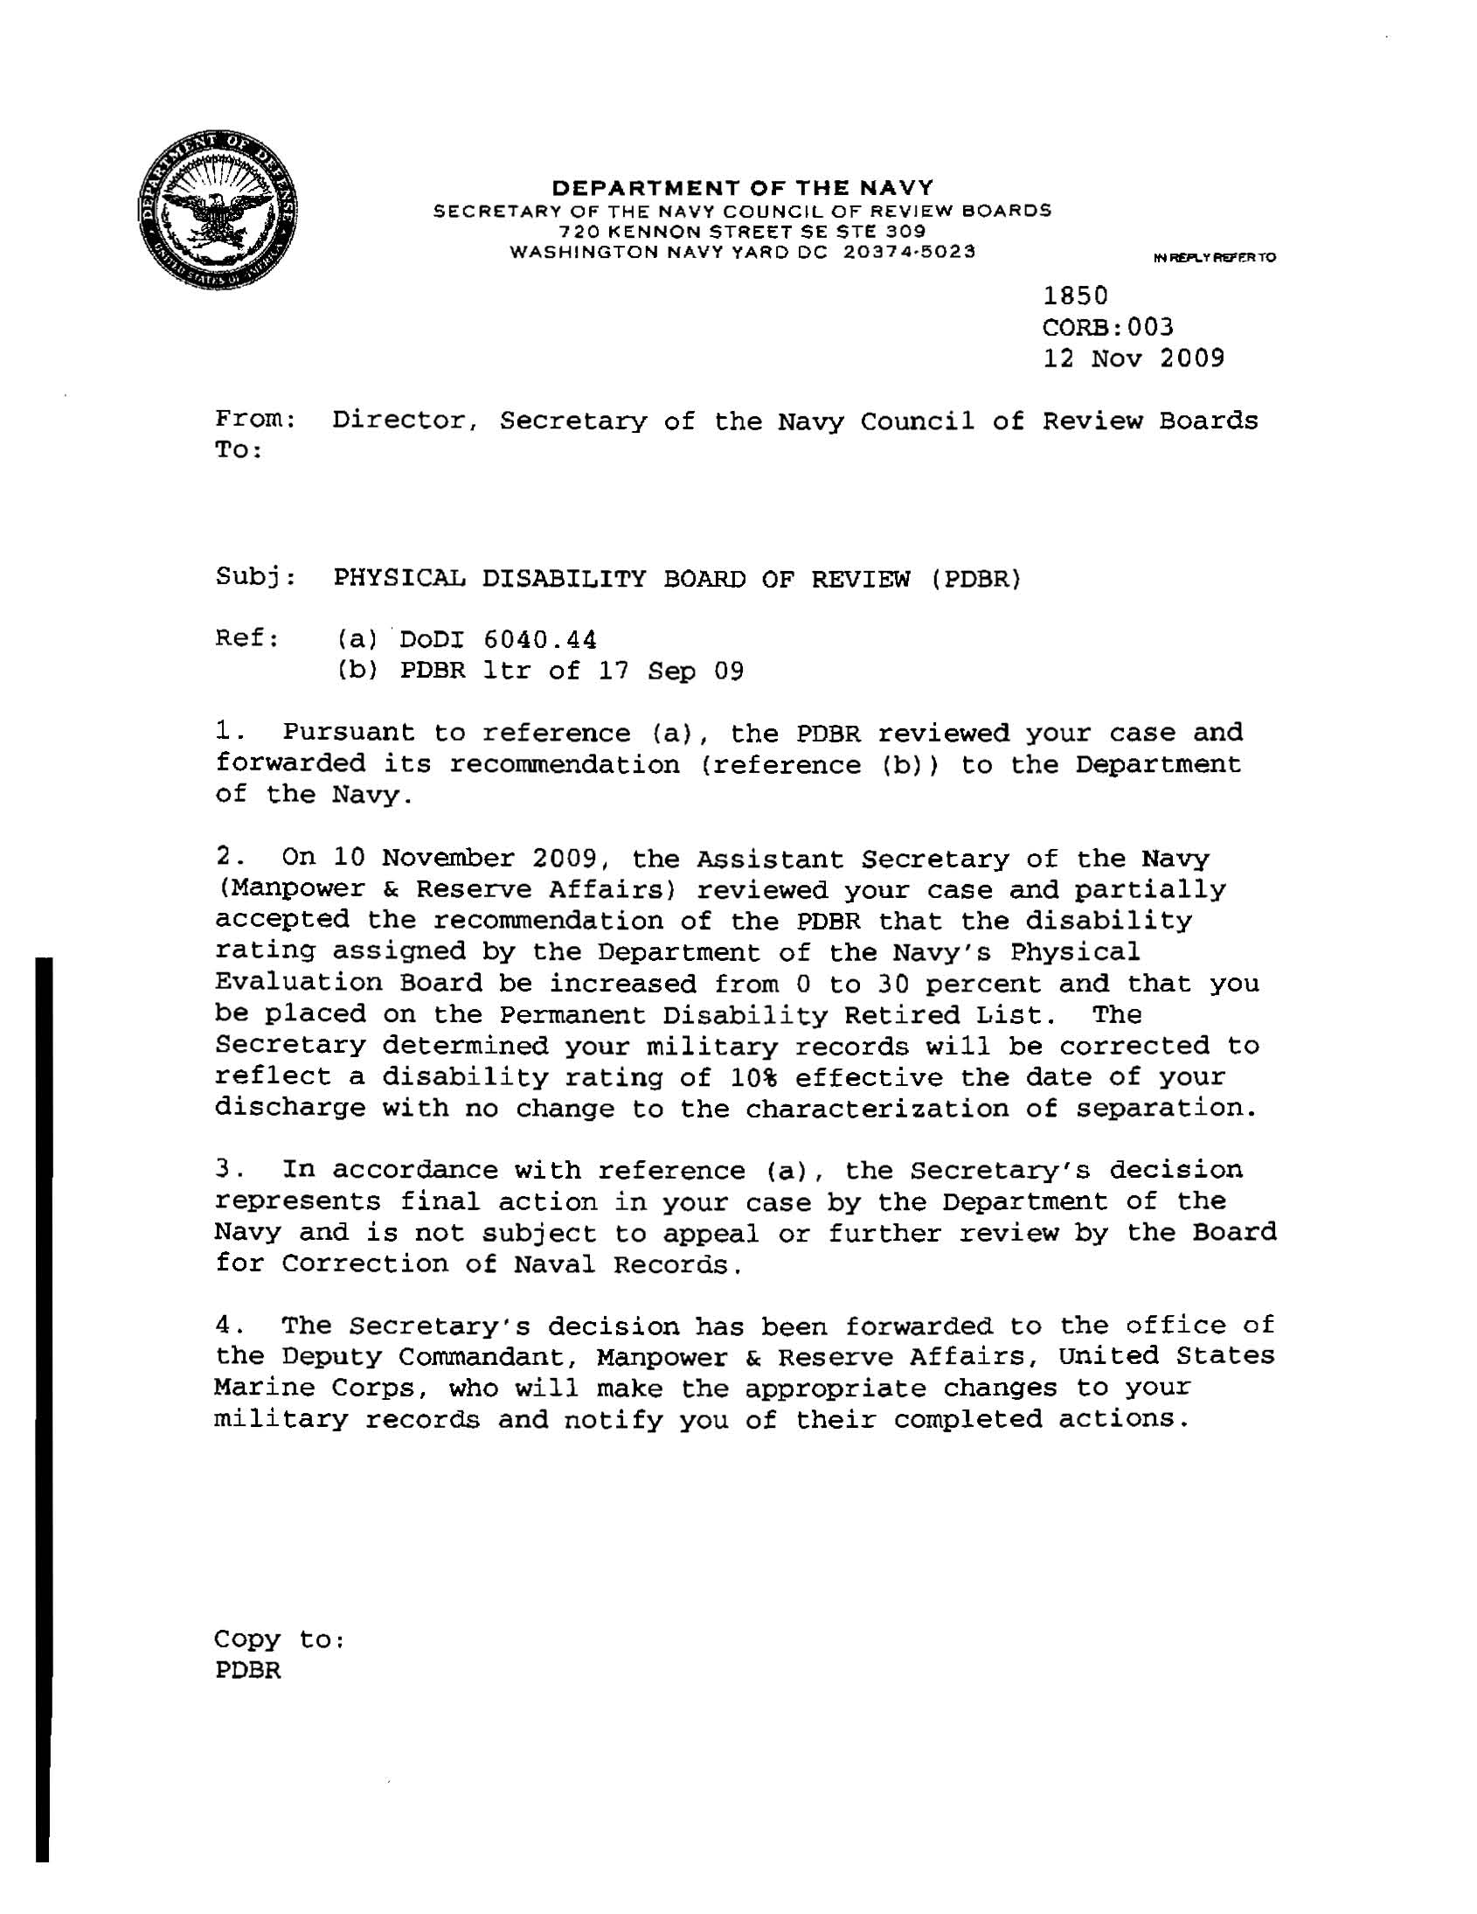

Dissenting opinion:

Initially the Navy PEB adjudicated the CI’s case based on one condition; Left Knee arthrosis, and he was found ‘Fit.’ The CI then requested a Reconsideration, based on a repeat Non-Medical Assessment (NMA) by a new commander. This NMA added an addendum addressing the cervical spondylosis, performed 2 weeks prior to the final PEB decision, which indicated that the cervical condition was unfitting. There was no mention in the MEB Exam or first Narrative of any cervical conditions for consideration. Further, the CI’s neck condition was not mentioned as a limiting condition on any of his Limited Duty forms, nor was neck or radiculopathy mentioned by his commander in the first NMA. This was written less than three months prior to the second NMA. Cervical spondylosis is a chronic condition, presumably unchanged over the period between the differing commander’s opinions. The first appearance of neck issues as possible unfitting conditions occurred after the CI had been found fit and was building a case for Reconsideration.

Specifically, the probative value of the second NMA is weakened by this circumstance. The second commander’s opinion does not specify how any of the conditions were unfitting regarding the physical requirements for performing as a repair technician. The cervical addendum, in fact, stated that the CI’s pain was made worse by late in the afternoon with golfing, running and driving. All of these activities are in excess of the CI’s daily job requirements. Specifically, the unfitting nature of the relatively mild impairment in sensation carried by the radiculopathy is too speculative for the Board to convincingly add it to the separation rating.

Based on these facts, I believe that the PEB adjudication fairly and accurately accounted for the CI’s cervical and radicular conditions at the time, by finding them ‘not unfitting.’ In consideration of VASRD §4.3, there is insufficient reasonable doubt to resolve in the CI’s favor. I do not believe that this Board’s threshold has been met for adding the cervical condition, much less the radiculopathy, as unfitting conditions for separation rating.

