ADDENDUM TO
RECORD OF PROCEEDINGS
AIR FORCE BOARD FOR CORRECTION OF MILITARY RECORDS

IN THE MATTER OF: DOCKET NUMBER: BC-2005-01371-2
INDEX CODE: 110.03

COUNSEL: NONE

HEARING DESIRED: NO

_________________________________________________________________

APPLICANT REQUESTS THAT:

His record be corrected to reflect 20 years of active duty service, a subsequent active duty retirement, and a pilot bonus he would have received had he been selected for any one of several fulltime positions he applied for but was never selected.

_________________________________________________________________

STATEMENT OF FACTS

On 16 May 2006, the applicant's request to change his records to show he was eligible for a 20-year active duty retirement and a pilot bonus contingent on his selection for any one of several active duty positions he applied for was considered and denied by the Board. For an accounting of the facts and circumstances surrounding the applicant’s request, and, the rationale of the earlier decision by the Board, see the Record of Proceedings at Exhibit E.

On 10 July 2006, he submitted a request for reconsideration contending the NYANG’s handling of his non-retention was not in accordance with ANG Instruction (ANGI) 36-2606 (Exhibit F). He has provided a personal statement and a narrative of a taped conversation between him and his commander that clearly demonstrates that the scheduled timeline (regarding the retention management program) mandated by the ANGI was not adhered to.

_________________________________________________________________

THE BOARD CONCLUDES THAT:

After again reviewing this application and the evidence provided in support of his appeal, we remain unpersuaded that the applicant should be granted a 20-year active duty retirement nor be given a pilot bonus even he admits would only be granted were he to have been selected for one of several active duty positions on his base. As previously noted, the selecting official and the State Adjutant General are responsible for hiring personnel against vacant positions in the ANG. We carefully considered the statements provided by the applicant and while we believe the evidence to be new and relevant, it is not of such significance as to alter our original decision. Accordingly, the applicant’s request is not favorably considered.

_________________________________________________________________

THE BOARD DETERMINES THAT:

The applicant be notified that the evidence presented did not demonstrate the existence of probable material error or injustice; and that the application will only be reconsidered upon the submission of newly discovered relevant evidence not considered with this application.

_________________________________________________________________

The following members of the Board considered this application in Executive Session on 27 September 2006, under the provisions of AFI 36-2603:

Mr. Thomas S. Markiewicz, Chair
Ms. Kathleen F. Graham, Member
Ms. Janet I. Hassan, Member

The following documentary evidence was considered:

Exhibit E. Record of Proceedings, dated 31 May 06,
with exhibits A through D.
Exhibit G. Applicant’s Letter, dated 10 Jul 06, w/atchs.

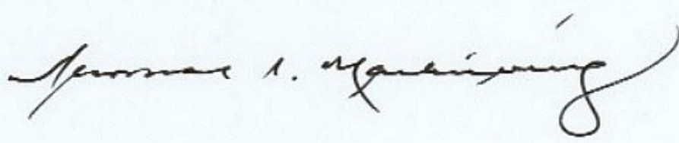

THOMAS S. MARKIEWICZ
Chair

